Lab 4 – Creating Dashboards in Tableau
Name: eamonn kelly
Student number = D24127620
Email address = D24127620@myTUDublin.ie
Date = 12th Oct 2026

The following is my submission for Lab 4 – Creating Dashboards in Tableau.

Part 1

Q1 . Part 1: Create a short critique of the existing visualisations at the below URL
https://www.dw.com/en/trains-vs-planes-whats-the-real-cost-of-travel/a-45209552

A: Critique

Overall structure
Mixture of text and embedded charts. Article provides comparison of plane vs train cost across 5 visualisations in terms of 3 key metrics, namely:
- Ticket prices
- CO2,
- journey times,

Data Visualisation 1 – Planes no always cheaper than trains.
- Legend at the top so have to refer up to that then back to chart which takes more effort for viewer. Put legend alongside the lines to make it easier to discern plane vs train#
- Combines 6 different small plots into a single X– Y plot, each with tis own axes.
  - X axis labellonly present on bottom plots. Should be smaller font and present in all.
  - Y axis cost
  - Headers embedded
- Overall easy to read, colours consistent and understand the story quickly enough, just legend being beside the line
- Message - took a while to figure out the combined messages. Plane prices increase I think in most instances. Train prices always increase close to departure time.

Alternative visualisation
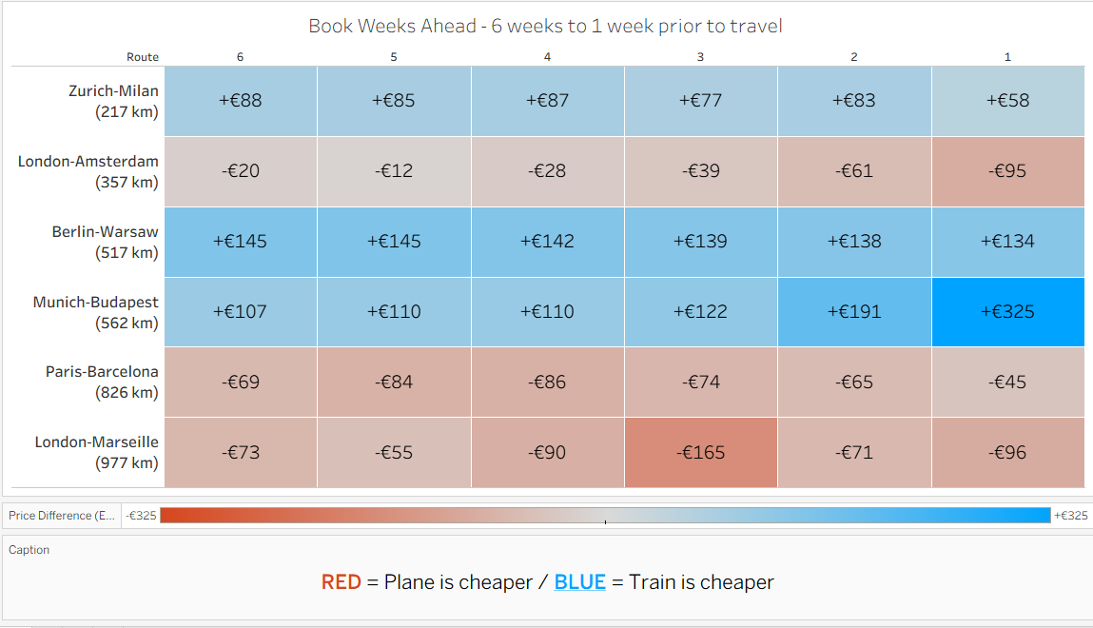
- Available on public Tableau here
https://public.tableau.com/app/profile/eamonn.kelly1417/viz/Vis1-PriceGapbetweenPlaneandTrainbybookingweeks/Vis1-pricegapheatmap?publish=yes

Data Visualisation 2 – difference in travel time: Actual / Displayed
- Consistent colours from last visualisation – red = plane and blue = train
- Dynamic dumb bell chart - data displaying and corresponding dynamic explanatory text, dynamic title.
  - think message is headline time of actual travel is faster by plane but when add in airport transit time difference is not that big and in two cases takes more time than train.
  - Hard to obtain the information easily, additional reasoning required

Alternative visualisation
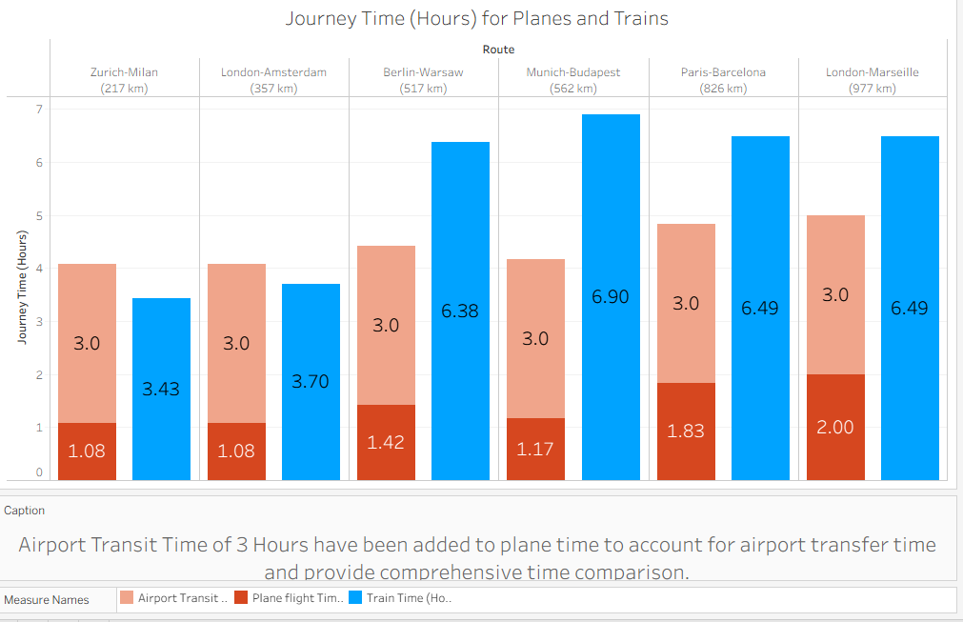

- Available on public Tableau here
https://public.tableau.com/app/profile/eamonn.kelly1417/viz/Vis2-JourneyTimeHoursforPlanesandTrains/Vis2-JourneyTime?publish=yes

Data Visualisation 3 – Plane vs train: Carbon dioxide emissions
- Circles a poor choice for comparison, areas often difficult to discern or get feel for ratio or proportional difference between the two values
- Numbers beside them help but require reading.
- Order of items is consistent as before i.e. Zurich-Milan first as in previous.
- Is the bigger the journey the bigger the CO2 difference used, not certain as berlin – warsaw might break that trend, bar chart may be better, or paired/clustered bar chart.

Alternative visualisation
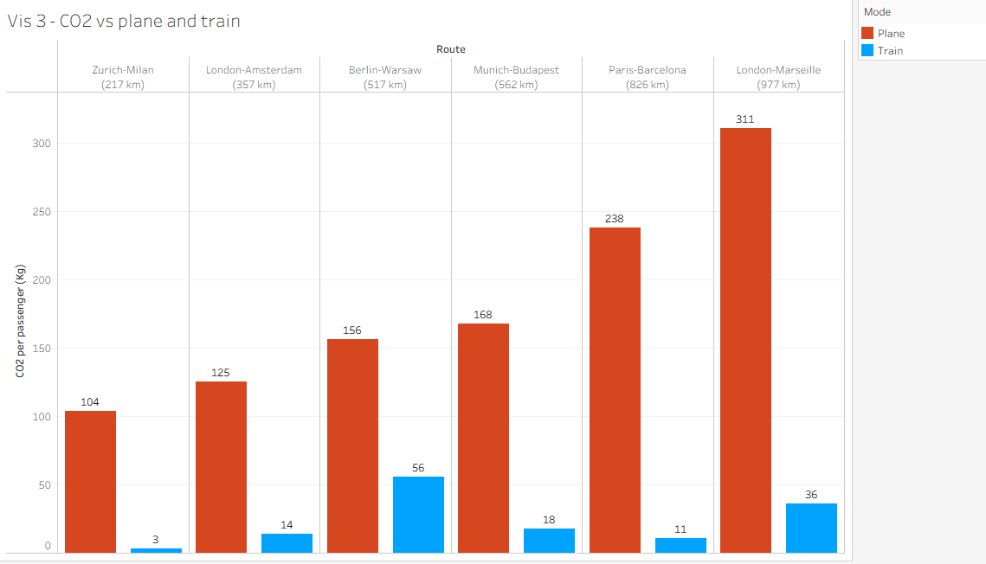

- Available on public tableau here
https://public.tableau.com/app/profile/eamonn.kelly1417/viz/Vis3-CO2vsPlaneandTrain/Vis3-CO2vsplaneandtrain?publish=yes

Data Visualisation 4 – Ticket Prices: What we pay / What price should be
- Again, dynamic data and text tales a while to get used to and figure out whats going on.
- Message I think is planes are sometimes cheaper but when social cost is added they are always ore expensive. A better graph choice may help get that across better
- Labelling and colours consistent again.
- Use of circles again, these are only for reference but after last plot have to decide if that have any weighted meaning as per last visualisation.
- Some dynamic plotted points for “planes” go past the €240 top x-axis value

Alternative visualisation
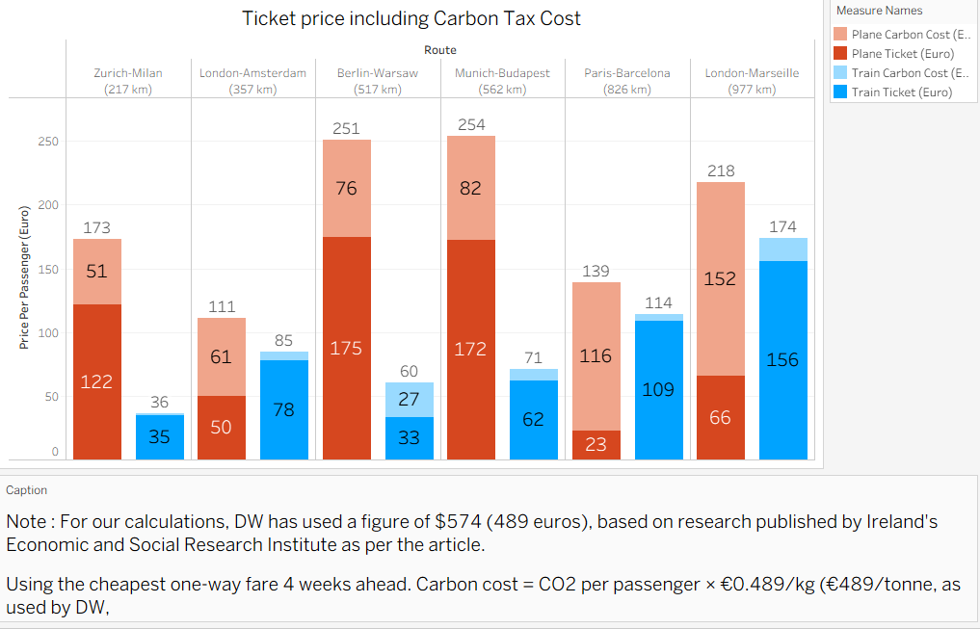

- Available on public tableau here
https://public.tableau.com/app/profile/eamonn.kelly1417/viz/Vis4-PlaneandTrainTicketpricesincudingCarbonTaxEuro/Vis4-PricevsCO2emissionscost?publish=yes

Data Visualisation 5 – Trains almost always beat planes: cheaper, faster less CO2-intensive
- 3 axes, triangular plot. Good idea to combine the 3 main metrics i.e. Time, Price and CO2, works well conceptually.
- Colours consistent as previously,
- Assumption is that the footprint/ area size is the comparison i.e. if blue is smaller area than red that implies it is better option. i.e. cheaper, quicker or uses less CO2. This isn’t stated however.
- Good choice of icons, know what they represent straight away.
- Colours consistent again. Used to legend now, know planes = red, trains = blue
- Terms “Assumed” and “Realistic”, takes a moment to understand what they represent, needs better labelling so intuitive
- Don’t have scales on the axes, so not really sure if they compare consistently across all routes.

Alternative visualisation
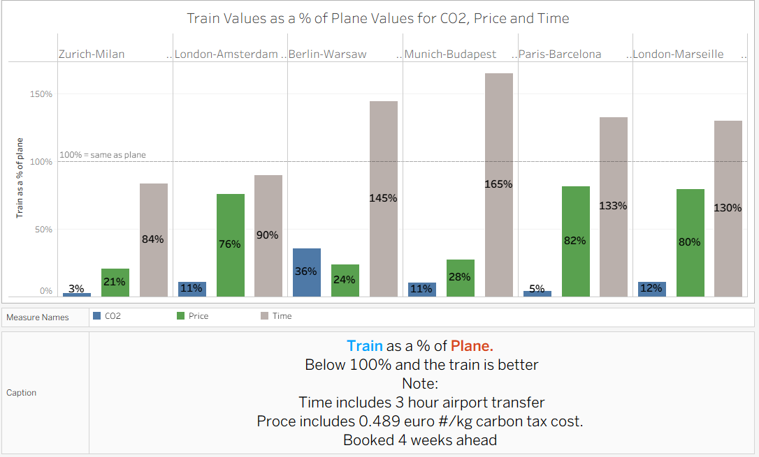

- Available on public tableau here
https://public.tableau.com/app/profile/eamonn.kelly1417/viz/Vis5-TrainandPlanecomparisonacrossCO2ProceandTime/vis5-TrainvsPlaneTEuroCOP2?publish=yes

Part 2
Dashboard of the 5 alternative visulaisations

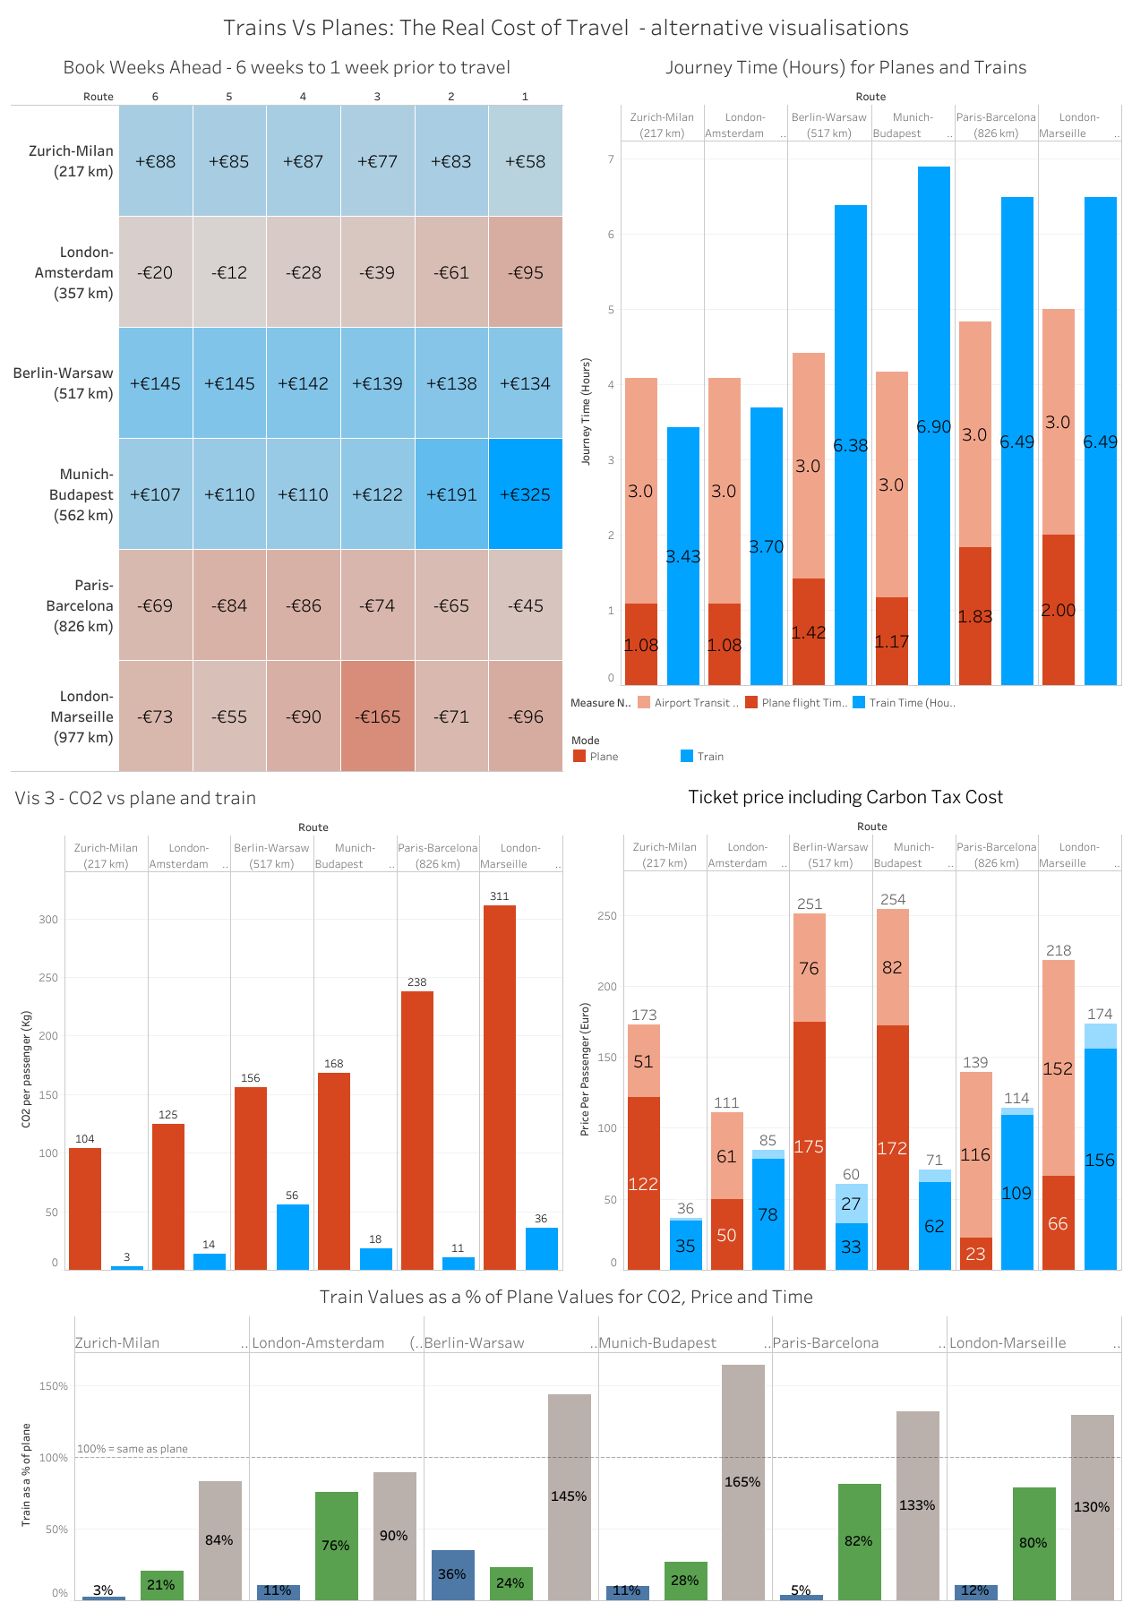

Available on public Tableau here
https://public.tableau.com/app/profile/eamonn.kelly1417/viz/Vis6-Dashboard-TrainsvsPlanes/Dashboard-TrainsvsPlanes?publish=yes

